 |  | 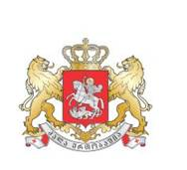 |  |  | 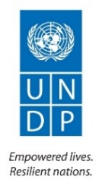
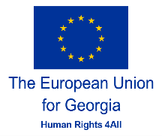 | 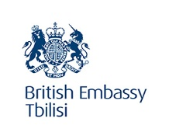 |  | 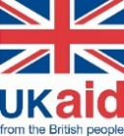 |  | 
Conference
See, Hear, Take a Step
Hotel Radisson Blu Iveria Tbilisi
Tuesday, 3 December 2019
DRAFT Agenda
09:30 – 10:00 | Registration / Welcome Coffee
10:00 – 10:10 | Screening of the Video
10:10 – 11:00 | Opening Remarks  Moderator: Louisa Vinton, UNDP Resident Representative in Georgia  - Giorgi Gakharia, Prime Minister of Georgia  - Archil Talakvadze, Speaker of the Parliament of Georgia  - Ekaterine Tikaradze, Minister of Internally Displaced Persons from Occupied Territories, Labour, Health and Social Affairs of Georgia  - Kakha Kaladze, Mayor of Tbilisi  - Carl Hartzell, Ambassador of the European Union to Georgia  - Ulrik Tidestrom, Ambassador of Sweden  - Justin McKenzie Smith, the British Ambassador to Georgia  - Nino Lomjaria, Public Defender of Georgia
11:00 – 11:15 | Coffee Break
11:15 – 12:00 | Panel 1: State Policy on Persons with Disabilities  Moderator: Eka Skhiladze, Deputy Public Defender  - Natalia Jaliashvili, Head of Human Rights Secretariat – the Vision of the State on the coordination mechanism under CRPD Article 33.1 and the action plan on rights of persons with disabilities under National Human Rights Strategy  - Rati Ionatamishvili, Member of Parliament – Status of ratification of Optional Protocol to CRPD  - Ministry of Justice – Georgia’s Draft Law on Disability  - Guram Chkhaidze, Founder of “Accessible Environment for Everyone” – the importance of consistent state policy for people with disabilities
12:00 – 12:30 | Discussion
12:30 – 13:00 | Panel 2: AI and Robotics for People with Disabilities  Moderator: Nikoloz Kobakhidze, Artificial Intelligence Business Association  - Keynote Speaker: Irakli Beridze, Head of Centre for Artificial Intelligence and Robotics United Nations, UNICRI  - Mariam Lashki, Deputy Chairperson of Georgia’s Innovation and Technology Agency – Start-ups for persons with disabilities
13:00 – 13:15 | Discussion
13:15 – 14:00 | Lunch
14:00 – 14:45 | Panel 3: Accessibility  Public Services  Moderator:  - Deputy Minister of Internally Displaced Persons from Occupied Territories, Labour, Health and Social Affairs of Georgia – Healthcare and Social services for persons with disabilities  - Eka Dgebuadze, Head of Inclusive Education Unit of the Ministry of Education - “Improving State Services Supporting Inclusive Education in Georgia”  - Soso Giorgadze, Head of Public Service Hall – Improved accessibility to the public services at the Public Service Hall  - Maguli Shagashvili, UNDP Consultant – Municipal Social Services for Persons with Disabilities  - Representative of Disabled Persons’ Organization or NGO working on Disability issues
14:45 – 15:00 | Discussion
15:00 – 15:15 | Coffee Break
15:15 – 16:00 | Physical Environment  Moderator:  - Davit Gigineishvili, Head of Technical and Construction Supervision Agency, Ministry of Economy and Sustainable Development of Georgia – Standard for Accessible and Usable Buildings and Facilities  - Parliament of Georgia - Accessible Parliament for all  - Giga Sopromadze, Executive Secretary of the Council of Persons with Disabilities, Tbilisi City Hall  - Nino Tvaltvadze, Deputy Mayor of Kutaisi Municipality – Rehabilitation of old district of Kutaisi and its adaptation to the needs of persons with disabilities  - Mariam Mikiashvili, Founder of “Mariani” – Needs of accessible physical environment for persons with disabilities
16:00 – 16:15 | Discussion
16:15 – 17:00 | Wrap up
17:00 – 19:00 | Reception hosted by Louisa Vinton, UNDP Resident Representative in Georgia
Start-ups will showcase assistive devices for people with disabilities in parallel of the sessions throughout the event

